**DAILY ONLINE ACTIVITIES SUMMARY**

|  |  |  |  |  |  |  |  |  |
| --- | --- | --- | --- | --- | --- | --- | --- | --- |
| **Date:** | **27/06/2020** | | | | | **Name:** | **NAIPUNYA VINOD NAIK** | |
| **Sem & Sec** | **IV SEM & A SECTION** | | | | | **USN:** | **4AL18CS050** | |
| **Online Test Summary** | | | | | | | | |
| **Subject** | | **DATA COMMUNICATION** | | | | | | |
| **Max. Marks** | | **30** | | **Score** | | | **25** | |
| **Certification Course Summary** | | | | | | | | |
| **Course** | **1) PROGRAMMING NETWORK APPLICATIONS IN JAVA**  **2) LEARN WEB DESIGN FROM SCRATCH**  **3) VULNERABILITY ANALYSIS COURSE FOR ETHICAL HACKING**  **4) WEBINAR ON C PROGRAMMING** | | | | | | | |
| **Certificate Provider** | | | **1) UDEMY**  **2) UDEMY**  **3) UDEMY**  **4) AIET** | | **Duration** | | | **1) 2 HRS**  **2) 34 MIN**  **3) 38 MIN**  **4) 1.5 HRS** |
| **Coding Challenges** | | | | | | | | |
| **Problem Statement: 1)** [**Write a C program to print kth digit**](https://github.com/orgs/alvas-education-foundation/teams/2nd-year/discussions/138)**.** | | | | | | | | |
| **Status: EXECUTED** | | | | | | | | |
| **Uploaded the report in Github** | | | | | **YES** | | | |
| **If yes Repository name** | | | | | <https://github.com/naipunya-naik/lockdown-coding/blob/master/C%20CODING/kth%20digit_27-06-2020.c> | | | |
| **Uploaded the report in slack** | | | | | **YES** | | | |

Online Test Details: (Attach the snapshot and briefly write the report for the same)

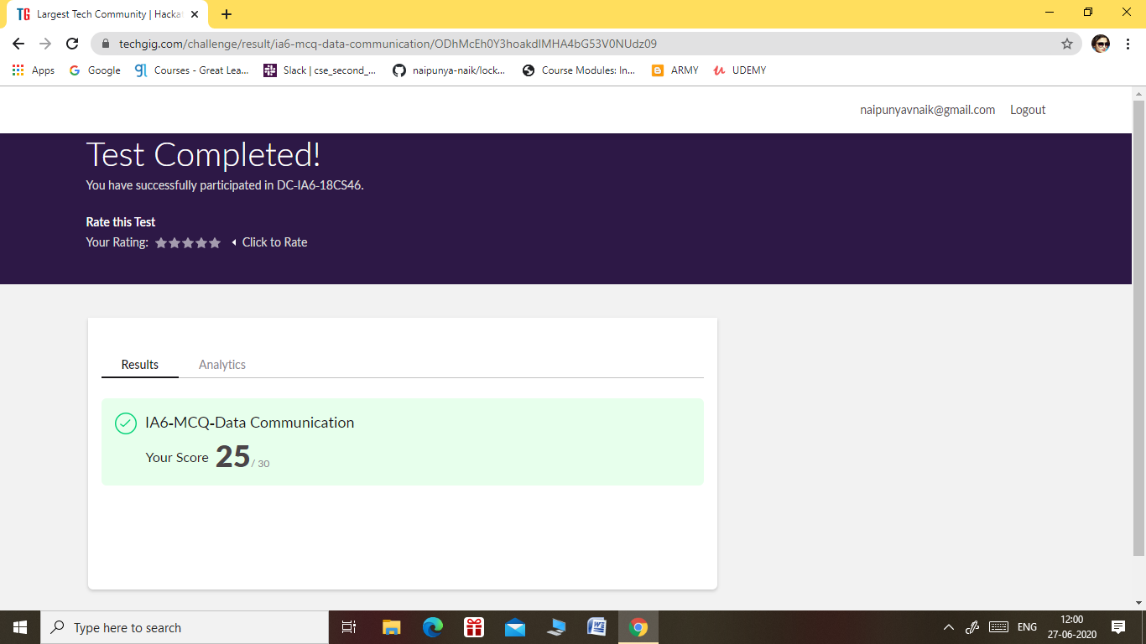

THE 6TH I.A TEST OF SUBJECT DATA COMMUNICATION WAS CONDUCTED ON 27 JUNE 2020.

* SUBJECT:- DATA COMMUNICATION
* SYLLABUS:- MODULE 5
* START TIME:- 11.30AM
* END TIME:- 12.00 PM
* DURATION:- 30 MIN
* NO.OF QUESTIONS:- 30
* TOTAL MARKS:- 30
* EACH QUESTION CARRIED 1 MARK

Certification Course Details: (Attach the snapshot and briefly write the report for the same).

1. CERTIFICATION COURSE NAME:- **PROGRAMMING NETWORK APPLICATIONS IN JAVA**



IN THIS CERTIFICATION COURSE , I LEARNT THE ABOUT PROGRAMMING APPLICATIONS IN JAVA.

1. **LEARN WEB DESIGN FROM SCRATCH**



IN THIS COURSE I LEARNT ABOUT WEB DESIGN FROM SCRATCH,WITH TUTORIALS AND RELATED MATERIALS.

1. **CERTIFICATION COURSE NAME:-**

**VULNERABILITY ANALYSIS COURSE FOR ETHICAL HACKING**

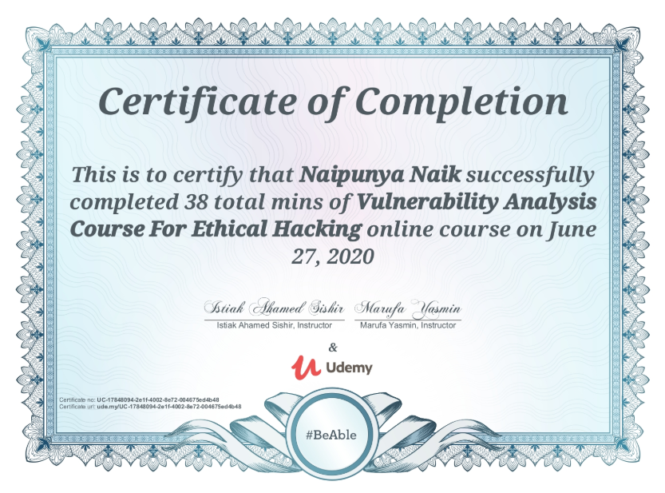

IN THIS COURSE I LEARNT THE APPLICATION OF VULNERABILITY ANALYSIS FOR ETHICAL HACKING.

1. WEBINAR ON C++ PROGRAMMING

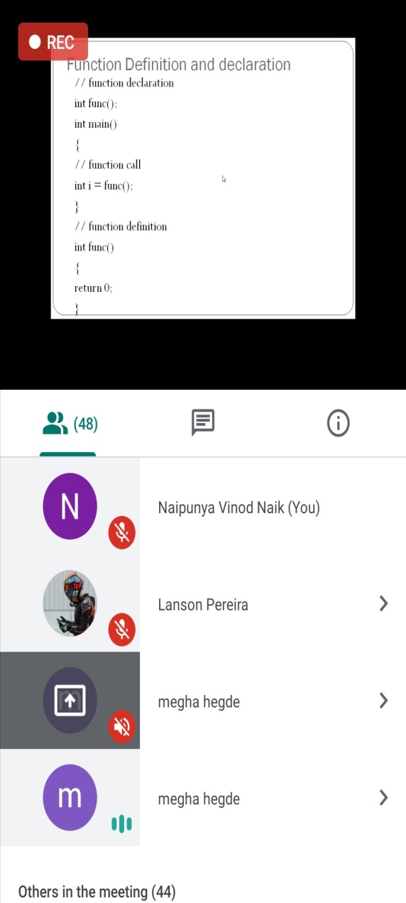 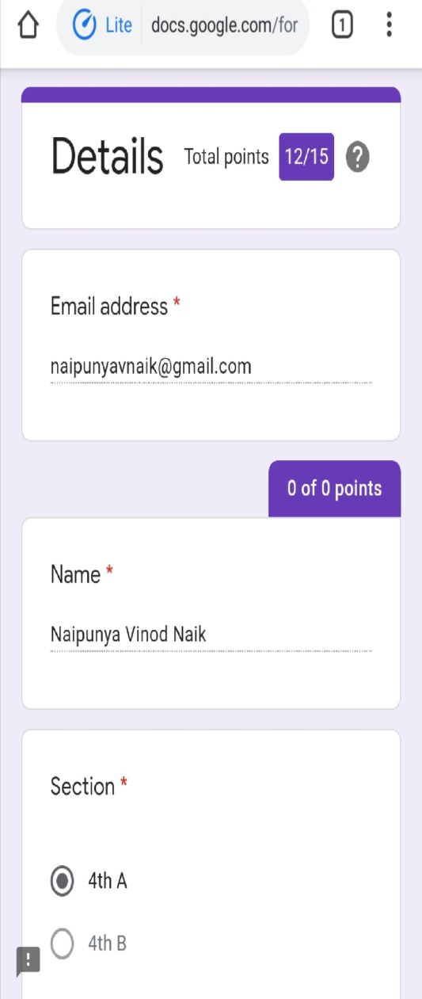

THESE ARE THE SNAPSHOTS OF WEBINAR OF C PROGRAMMING

CONDUCTED BY:- MS. MEGHA.D.HEGDE,ASST.PROF, AIET

SUBJECT:- WEBINAR ON C PROGRAMMING

TOPICS COVERED TODAY:-

* FUNCTION DEFINITION AND DECLARATION
* CONDITIONAL STATEMENTS
* LOOPS
* ARRAYS
* DURATION:- 1.5 HRS
* FROM 2.30PM TO 4.00 PM
* THE WEBINAR COMPRISED OF QUIZ WHICH HAD 15 QUESTIONS.
* EACH QUESTION CARRIED 1 MARK

Coding Challenges Details: (Attach the snapshot and briefly write the report for the same).

PROBLEM STATEMENT:- [Write a C program to print kth digit](https://github.com/orgs/alvas-education-foundation/teams/2nd-year/discussions/138)

Top of Form

Bottom of Form

|  |
| --- |
| Given two numbers a and b, find kth digit from right of a^b.  Input:  The first line of the input contains T denoting the number of test cases.Each of the next T lines contains three space separated positive integers denoting the value of a , b and k respectively.  Output:  For each test case, output the kth digit from right of a^b in new line.  Constraints:  1<=T<=100 1<=a , b <=15 1<=k<=|totaldigits in a^b|  Example:  Input: 2 3 3 1 5 2 2  Output: 7 2  Hint Output: 1 Explanation 3^3 = 27 for k = 1. First digit is 7 in 27 Output : 2 Explanation 5^2 = 25 for k = 2. First digit is 2 in 25 |

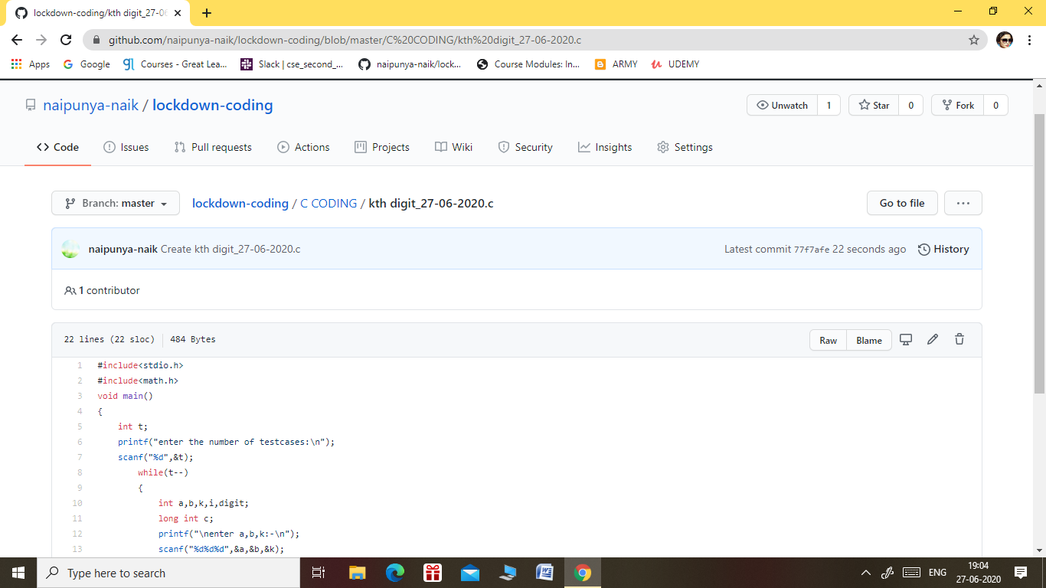

GITHUB REPOSITORY LINK:-

<https://github.com/naipunya-naik/lockdown-coding/blob/master/C%20CODING/kth%20digit_27-06-2020.c>